# **CS 1101-01: Programming Assignment Unit 5**

Godknows Egi

Bachelor of Science in Computer Science, Uopeople

CS 1101-01 - AY2024-T3: Iteration and Strings

Bianca Gilyot

March 7th , 2024

**Part 1**

Write program to display your name and perform following operations on it:

1. Display n characters from left. (Accept n as input from the user)
2. Count the number of vowels.
3. Reverse it.

**Solution**

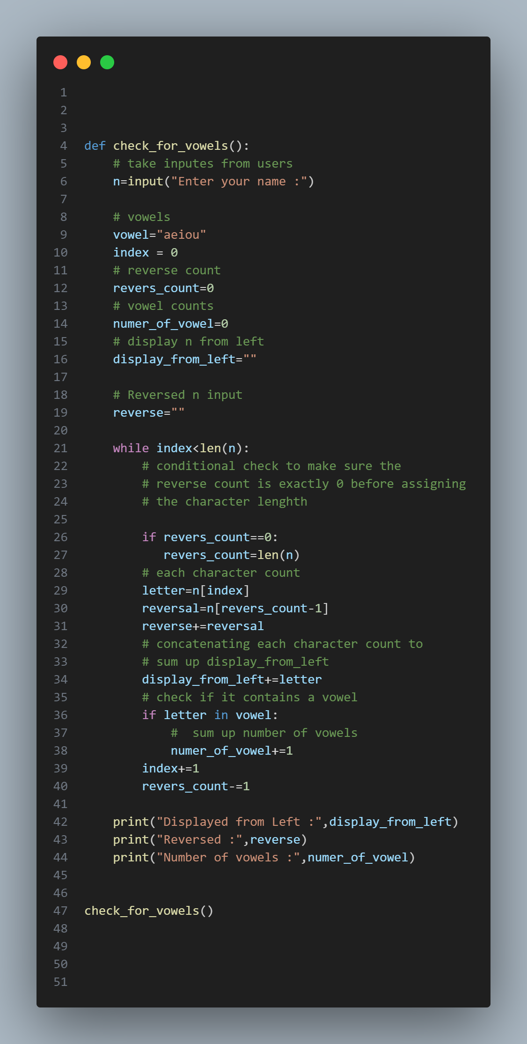

*Code file fig. 1*

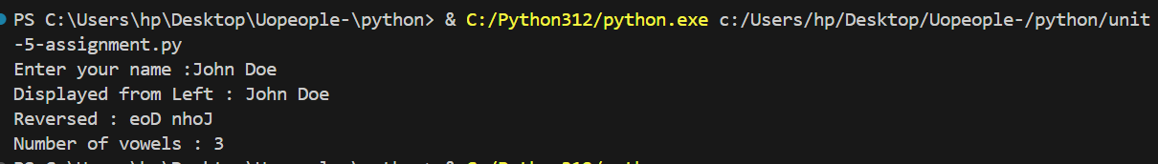

*Code output fig. 2*

1. **Function Definition:**

def check_for_vowels():

Firstly I defined a function called **check_for_vowels ,**  This function will be serve as the program wrapper.

1. **User input Variable:**

   # take inputes from users

    n=input("Enter your name :")

This variable takes user input and store them into the n varaible

1. **Vowels and Index:**

 # vowels

    vowel="aeiou"

    #index for loop

    index = 0

I defined another variable called **vowels** and **Index,**  The vowel holds all the vowel sounds in English language, While the Index variable holds the initial index count for the loop

1. **Initialized variables**

 revers_count=0

    # vowel counts

    numer_of_vowel=0

    # display n from left

    display_from_left=""

    # Reversed n input

    reverse=""

This line I have initialized the variables to hold the reverse count index, number of vowels, display **n** from left and vice versa

1. **While loop**

 while index<len(n):

This line starts a while loop that iterates over each character in the user's input (n).

1. **Reverse count**

 # conditional check to make sure the

        # reverse count is exactly 0 before assigning

        # the character lenghth

        if revers_count==0:

           revers_count=len(n)

This conditional check ensures that the reverse_count is exactly 0 before assigning the character length of the input (n) to it.

1. **Character Processing:**

 # each character count

        letter=n[index]

        reversal=n[revers_count-1]

These lines extract the current character (letter) and its counterpart from the reverse (reversal) for further processing.

1. **Building Reversed String:**

  # Building reversed string

        reverse+=reversal

This line appends the reversed characters to the reverse string.

1. **Building Display from Left:**

 # concatenating each character count to

        # sum up display_from_left

        display_from_left+=letter

This line appends each character to the display_from_left string to display the name from left to right.

1. **Vowel Check:**

 # check if it contains a vowel

        if letter in vowel:

            #  sum up number of vowels

            numer_of_vowel+=1

This block checks if the current character is a vowel and increments the **numer_of_vowe**l count if it is.

1. **Incrementing Index and Reverse Count:**

 index+=1

 revers_count-=1

These lines increment the index and decrement the reverse_count for iterating over the characters and their reverses.

1. **Output:**

  print("Displayed from Left :",display_from_left)

    print("Reversed :",reverse)

    print("Number of vowels :",numer_of_vowel)

These lines print the results: the name displayed from left to right, the reversed name, and the number of vowels in the name.

1. **Function Call:**

check_for_vowels()

This line calls the check_for_vowels function to execute the defined logic.

**This code essentially takes a user's name as input as instructed on my assignment above, processes it character by character, builds a reversed version of the name, counts the number of vowels, and prints the name displayed from left to right, the reversed name, and the count of vowels.**